Install and Confirm KNative CLI Plugin

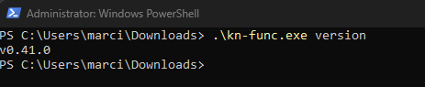

Create a KNative Function

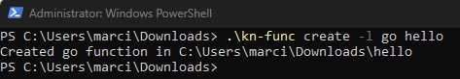

Run function on local registry

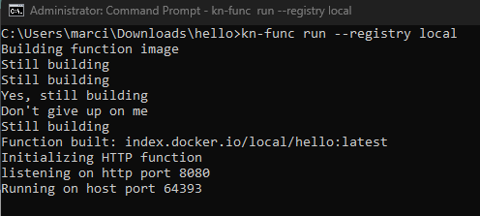

Invoke Function



